Name: | ___________________________________________________ |  |  |  | Date: __________
 | Year 8 Mathematics  Test 3, 2015  Topics – Volume, Fractions, Decimals, Percentages
Total Time: | 4 minutes
Total Reading: | 4 minutes
Total Working: | 55 minutes
Weighting: | % of the year.
CALCULATOR FREE

Time: | 27 minutes | Marks for Section 1: |  | 32
Reading: | 2 minutes | Equipment Allowed: |  | Nil
Working: | 25 minutes

________
64

= %

1. | [20 marks]
 | MULTIPLE CHOICE: Circle the answer you think is most correct. Each question is worth 1 mark

a) | What fraction of the circle is shaded?
 | 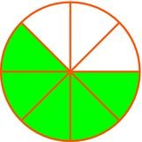
 | A |  | B |  | C |  | D
b) | What decimal fraction is represented by the shaded part of the rectangle?
 | 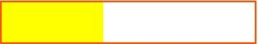
 | A | 0.2 | B | 0.4 | C | 0.5 | D | 0.6
c) | Write in simplest form.
 | A |  | B |  | C |  | D
d) | Which of the following is an improper fraction?
 | A |  | B |  | C |  | D
e) | Write as an improper fraction.
 | A |  | B |  | C |  | D
f) | Write as a simplified mixed fraction.
 | A |  | B |  | C |  | D
g) | Write 0.36 as a simplified fraction.
 | A |  | B |  | C |  | D
h) | Change to a decimal.
 | A | 2.58 | B | 2.85 | C | 2.625 | D | 2.225
i) | Change to a decimal.
 | A | 0.56 | B | 0.83 | C |  | D
j) | What is the value of ? in
 | A | 4 | B | 5 | C | 12 | D | 18
k) | What is half of a half?
 | A |  | B |  | C |  | D
l) | Find
 | A |  | B |  | C |  | D
m) | Find
 | A |  | B |  | C |  | D
n) | Work out
 | A |  | B |  | C | 8 | D | 24
o) | Work out
 | A |  | B |  | C |  | D
p) | 25.073 ÷ 100 =
 | A | 0.025 073 | B | 0.250 73 | C | 2507.3 | D | 25 073
q) | Estimate an answer to
 | A | 2 | B | –1 | C | –2 | D | –3
r) | Which of these would give you the most money?
 | A | of $690 | B | of $500 | C | of $972 | D | of $480
s) | Find of 42.
 | A | 14 | B | 18 | C | 21 | D | 28
t) | What is 2% of 3000?
 | A | 0.6 | B | 6 | C | 60 | D | 600

SHORT ANSWER: Show full working out to be awarded maximum marks.

2. | [1 mark]
 | of a 20 ha paddock is no good for planting. How many hectares can be planted?

3. | [3 marks: 1, 1, 1]
 | Calculate each of the following:
 | a) |  | b)
 | c)

4. | [8 marks: 2, 2, 2, 2]
 | Calculate each of the following. (show full working)
 | a) |  | b)
 | c) |  | d)

Name: _____________________________________
CALCULATOR ALLOWED
Time: | 32 minutes | Marks for Section 2: | 32
Reading: | 2 minutes | Equipment Allowed: | 1 A4 page of notes,  Calculator
Working: | 30 minutes

5. | [5 marks: 1, 1, 1, 1, 1]
 | Insert <, =, or > to make true statements.
 | a) |  | b)
 | c) |  | d)
 | e)

6. | [1 mark]
 | What fraction of an hour is 24 minutes?

7. | [1 mark]
 | What percentage of an hour is 15 minutes?

8. | [2 marks]
 | Write in order from smallest to largest:
 | , 0.26, –0.27, ,

9. | [3 marks]
 | Fill in the missing spaces to make each row full of equivalent values. The first row has been done for you.

Decimal | Percentage | Fraction
0.45 | 45%
 | 30%
0.03

10. | [2 marks]
 | If $200 is increased by 15% and then decreased by 10% how much money remains?

11. | [3 marks: 1, 1, 1]
Michaela is saving up to buy a unicorn. Her parents offer to give her an extra 10% of any money she saves.
She earns the following amounts: $415.50, $1270, $1820.55; and saves all of it.
a) | How much has she saved?
b) | How much will her parents give her?
c) | How much will she have in total to buy a unicorn?

12. | [2 marks: ½, ½, ½, ½ ]
 | Complete the following volume conversions:
 | a) | 2.5 cm³ = _______________ mm³ | b) | 0.389 km³ = _______________ m³
 | c) | 18967 cm³ = _______________ m³ | d) | 47890 cm³ = _______________ L

13. | [2 marks: 1, 1]
 | Determine the volume of each of the following shapes by counting cubes. Each cube is one cubic centimeter. Don’t forget about the hidden cubes.
 | a) | 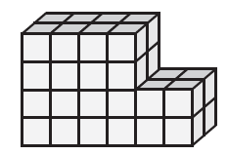 | b) | 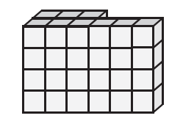

14. | [8 marks: 2, 2, 2, 2]
 | Determine the volume of each of the following shapes.
 | a) | 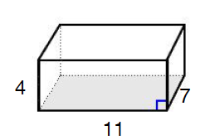 | b) | 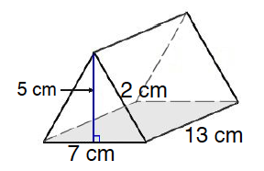
 | c) | 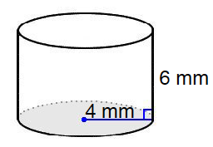 | d) | 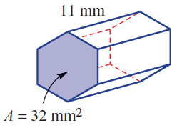

15. | [3 marks]
David is filling his petrol container for his lawn mower on a cheap fuel day.
His tank is cylindrical, with a radius of 10 cm, and a height of 25 cm.
If he only needs to fill 80% of his tank with petrol, how much fuel will he purchase? Give your answer in litres.

END OF SECTION TWO

